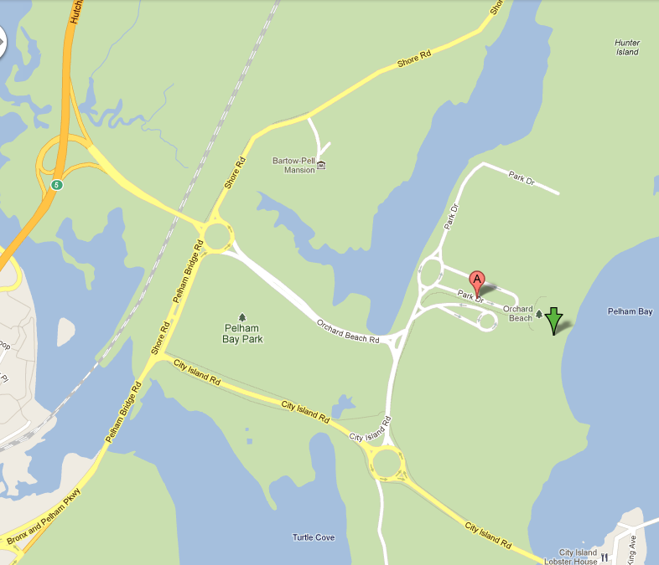
Orchard Beach is a public beach in the borough of the Bronx in New York City. The beach is part of Pelham Bay Park

