<1> Oceanside
Home -> Grand Central -> Cross Island -> Southern State Parkway E. ; then GPS to 500 Slice Dr., Oceanside, NY 11572
back2Home: to 711 School Dr., then to Home

<2> from Oceanside to Rockaway Beach at Beach 60th Street (see also 9/3/2011 & 6/26/2010 bblog) - 30 min.
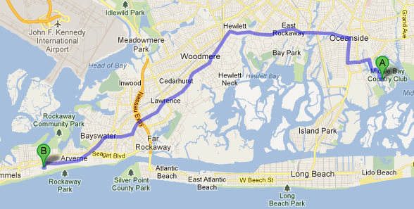
GPS : via 1346 Broadway, Hewlett, NY 11557 which will bring me to St Joseph's Catholic Church on Broadway.

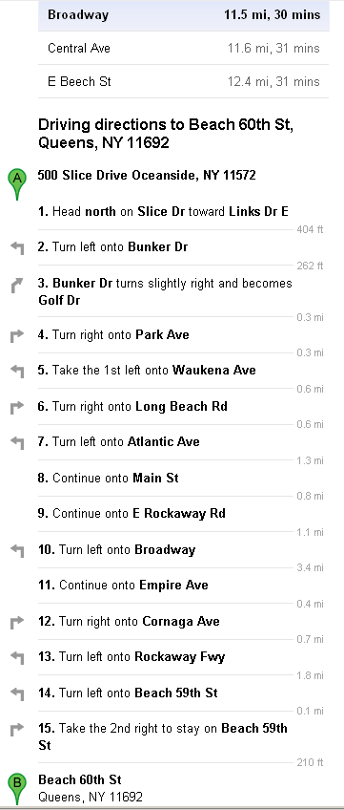
Note: on 9/3/2011, from Rockaway to Oceanside, taking Nassau Expressway/NY878 paid $2.00 toll for Atlantic Beach Bridge, also via Long Beach Blvd. So avoid Long Beach & Atlantic Beach Bridge!

<3> from Rockaway Beach to Fort Tilden, then walk to Breezy Point Tip (2-mile walk)
GPS to Fort Tilden or 1 Beach 193rd St [but the actual location is about 169th St.], Rockaway Point/Beach, NY 11697; Take exit 11S of Belt Pkwy for Flatbush Ave S toward Rockaway; back home can take route along Rockaway Park avoiding tolls.
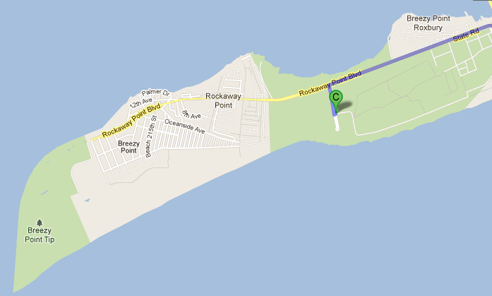
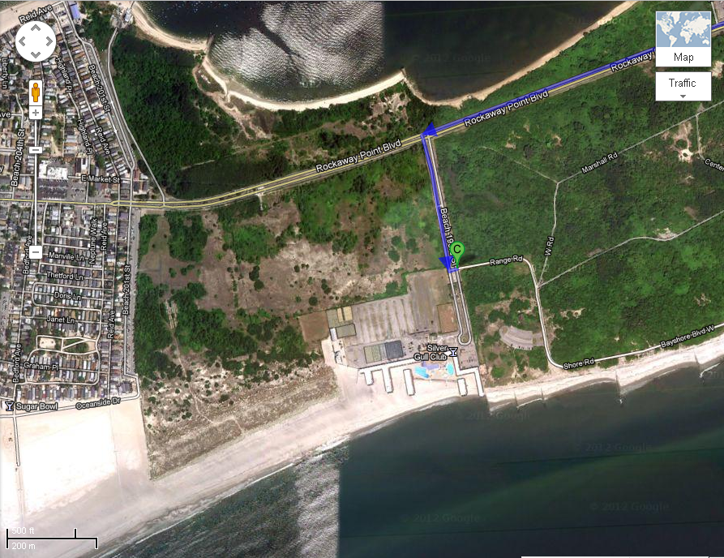
According to http://www.nyharborparks.org/visit/brpo.html , Breezy Point Tip is reachable by walking:
Get map & directions to Fort Tilden via other transportation; then walk along Fort Tilden beach to reach Breezy Point Tip.

CONTACT
Gateway NRA (NPS), 718-318-4300. Or 718-338-3799

