Marine Nature Study Area (Oceanside)
Take Southern State Parkway to exit 20S (Grand Avenue-Baldwin). Pass Sunrise Highway, then turn right on Atlantic Avenue. Turn left on Waukena Avenue and start looking for signs to the nature center. Turn left on Park Avenue, then left on Golf Drive to Slice Drive.
from home to 500 Slice Drive, Oceanside, NY 11572 (Town of Hempstead : Marine Nature Study Area) - click to enlarge image:
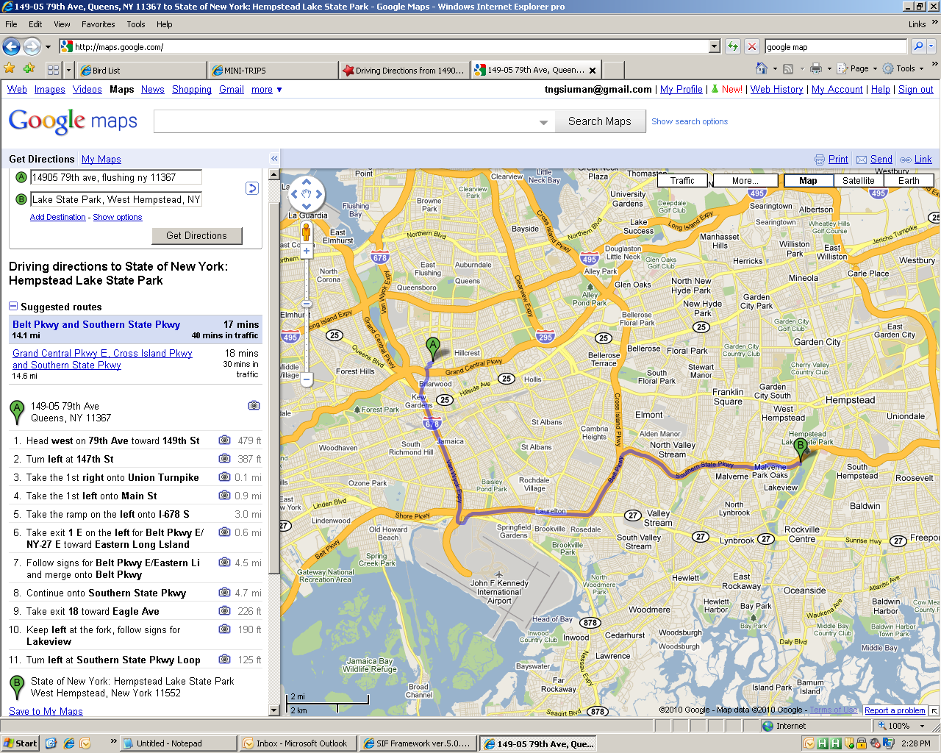
Return: 500 Slice Dr, Oceanside, NY 11572-5600 -> 711 School Dr, North Baldwin, NY 11510-1121


